Handson 06 - **Solution**

Demonstrate running Apache Kafka on the local system and produce and consume messages using Kafka Console Producer and Kafka Console Consumer.

Steps:

1. Install Apache Kafka on your system
   1. Visit the following link

<https://kafka.apache.org/downloads>

* 1. Click on the latest version ( in this case Scala 2.13)

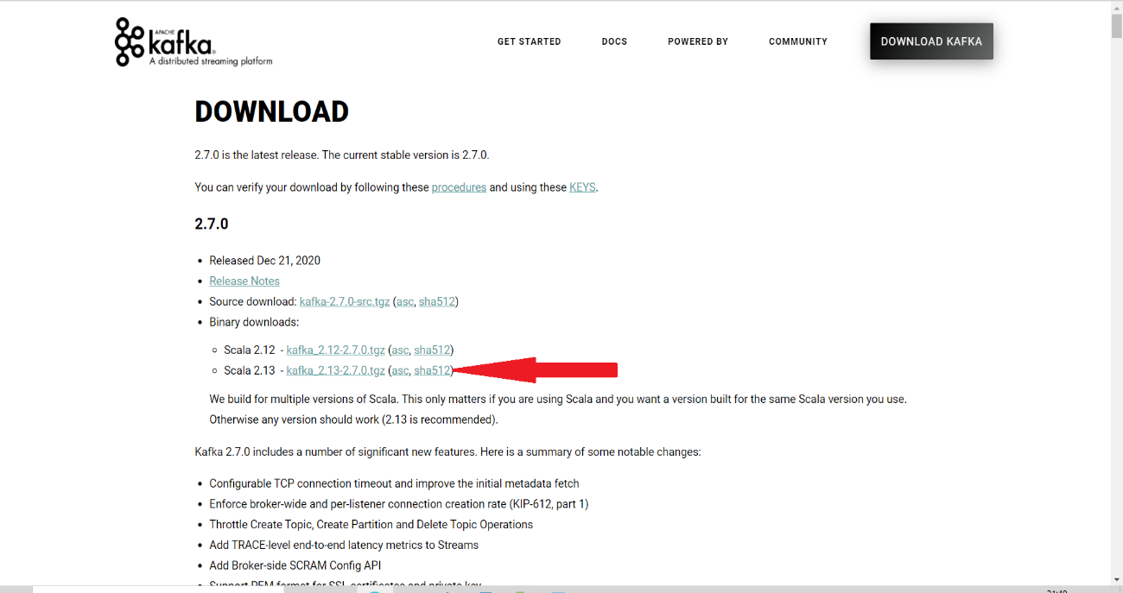

* 1. You will be taken to the screen shown below. Download from the first link shown.

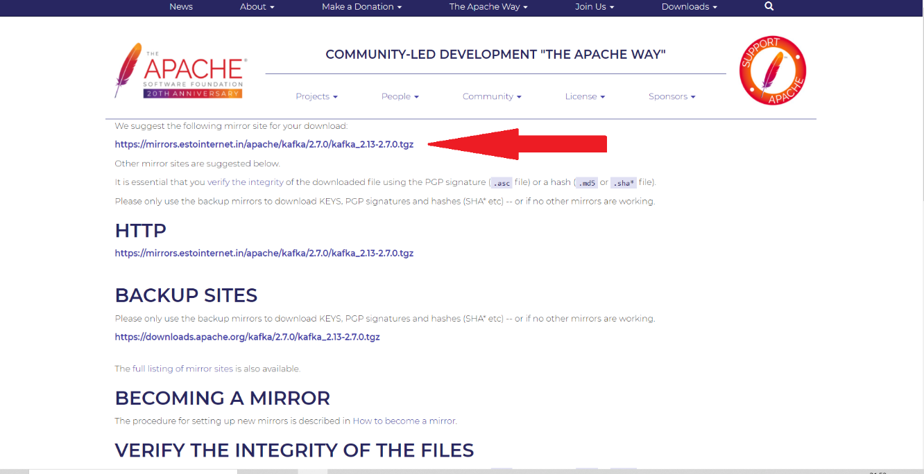

* 1. You will get kafka_2.13-2.7.0.tgz once download is completed
  2. Extract this downloaded file.

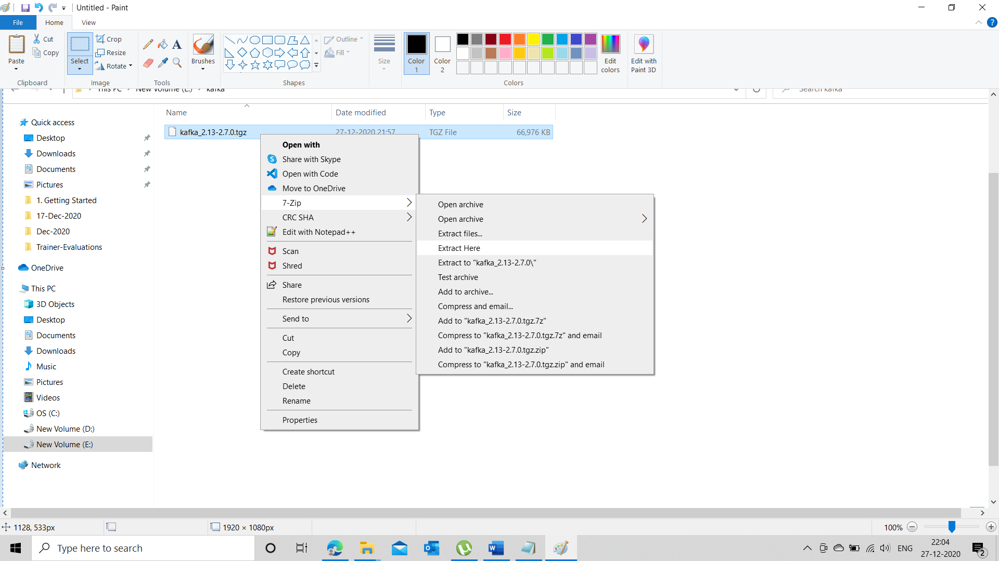

* 1. Once extracted, you will get a file with “.tar” extension.
  2. Extract the “.tar” file.

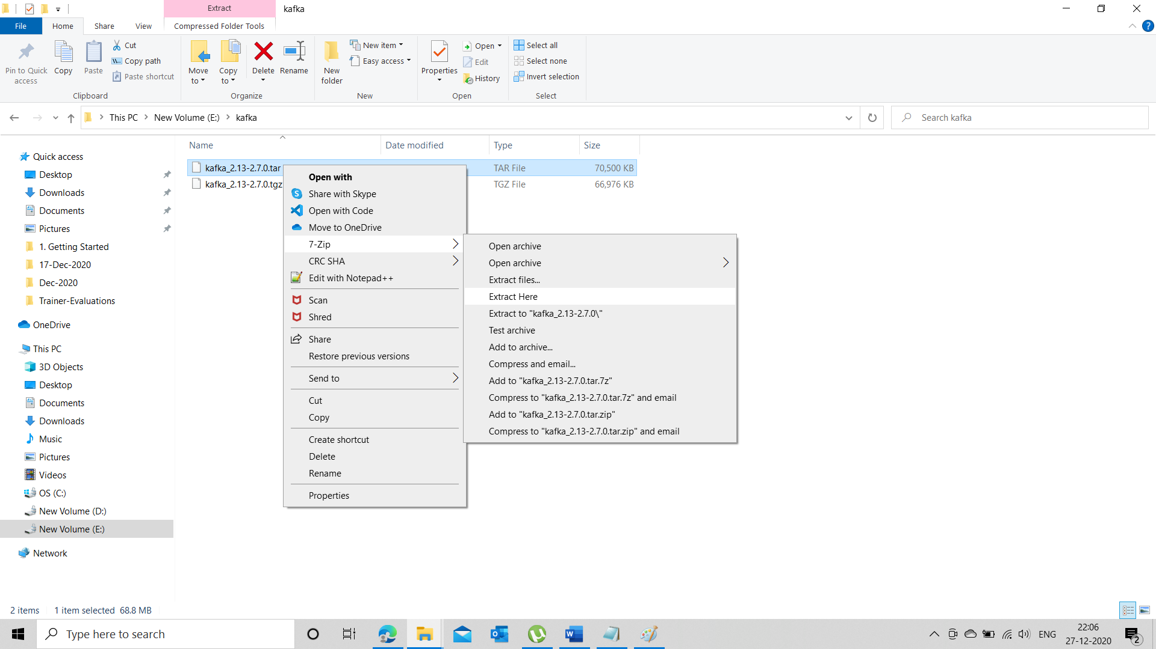

* 1. You will get a folder with the same name as the file as shown in the screen below.

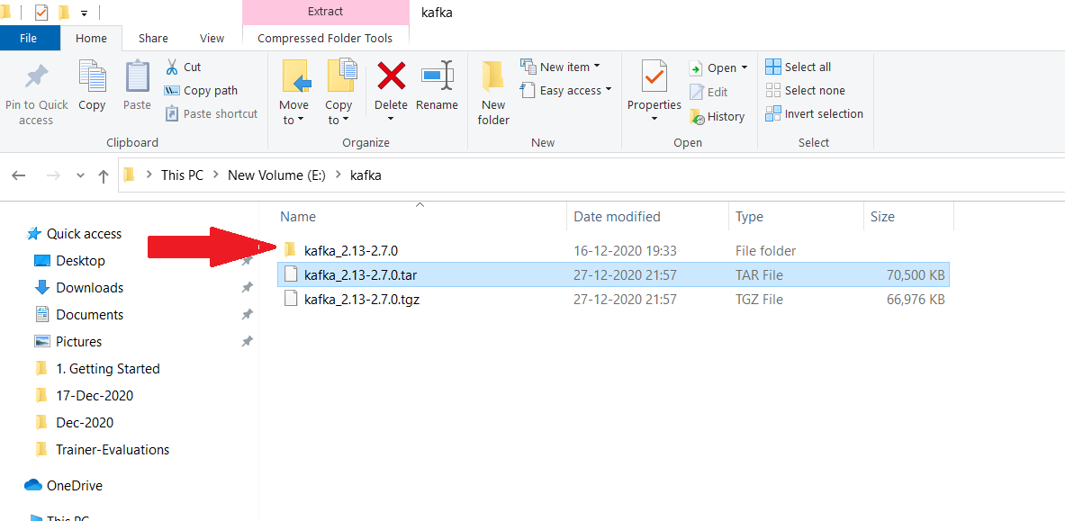

* 1. Open the folder. You can see the contents as shown below.

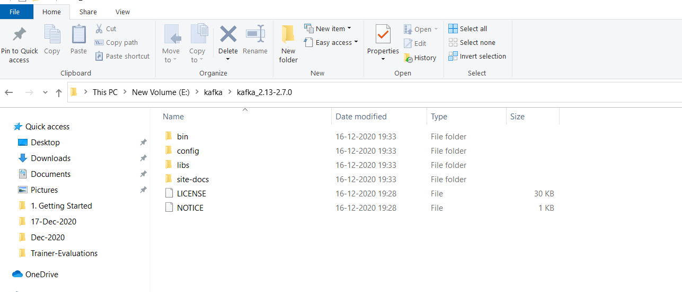

* 1. Set the path to the “windows” folder inside the “bin” folder
  2. Open the command prompt /terminal and issue the following command.

**Kafka-topics**

* 1. If you are getting the following response, your installation is successful.

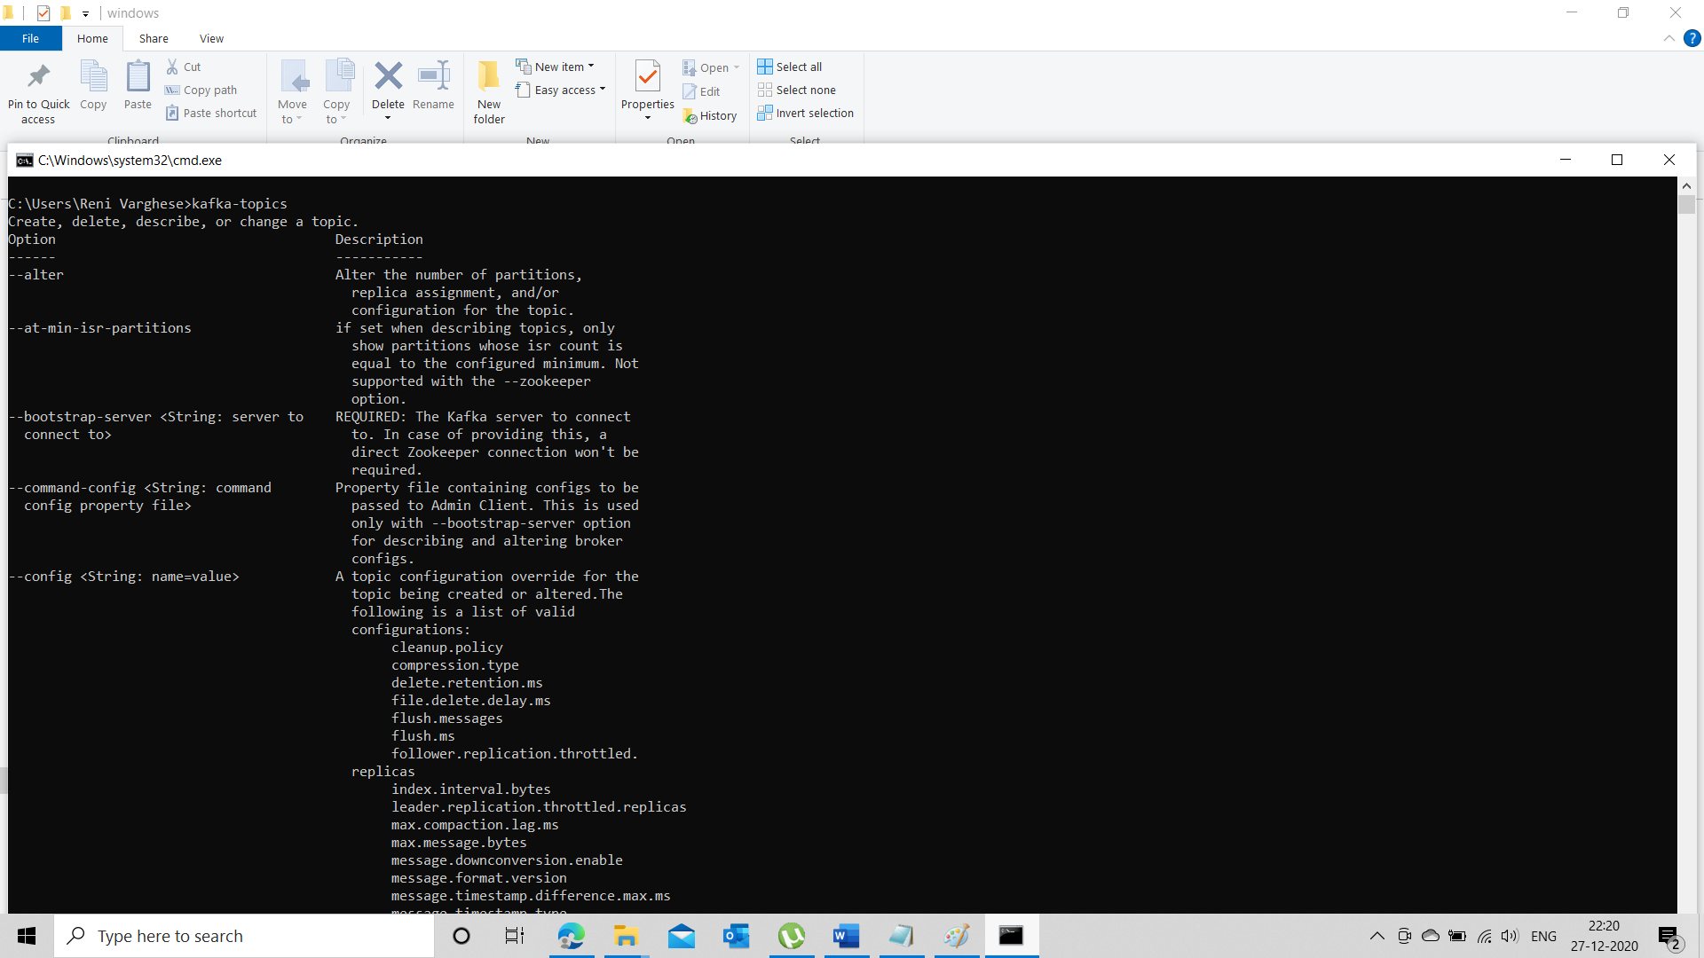

1. Go to the folder “kafka_2.13-2.7.0”
2. Create a folder named “data”
3. Move to the folder “data”
4. Create 2 folders. One with the name “zookeeper”, another with the name “kafka”

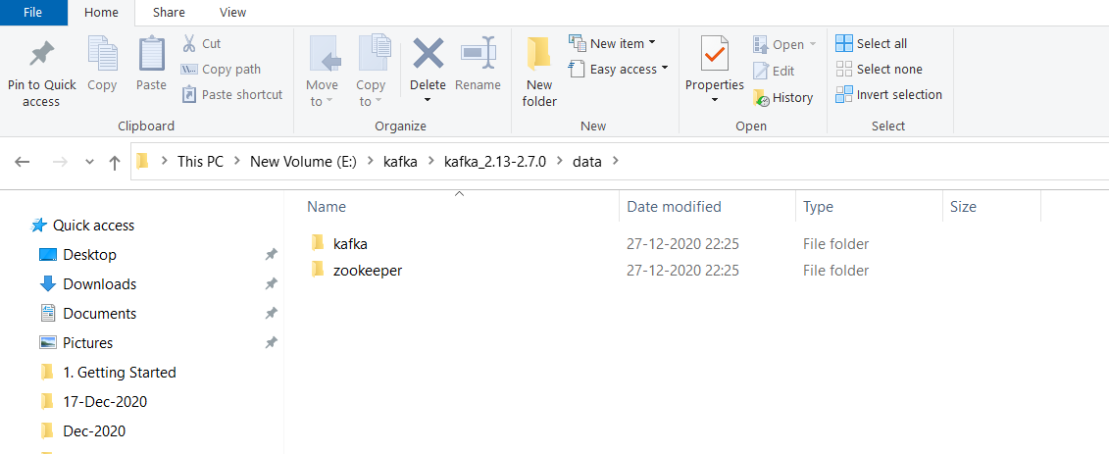

1. Copy the entire path to the “zookeeper” folder
2. Go to the configuration folder inside the ““kafka_2.13-2.7.0” folder

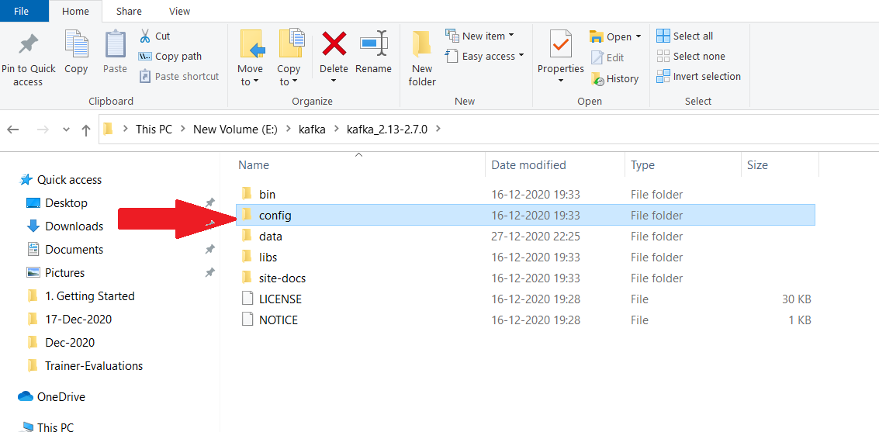

1. Open the zookeeper.properties file and paste the path to the zookeeper folder to the “dataDir” property as shown below.

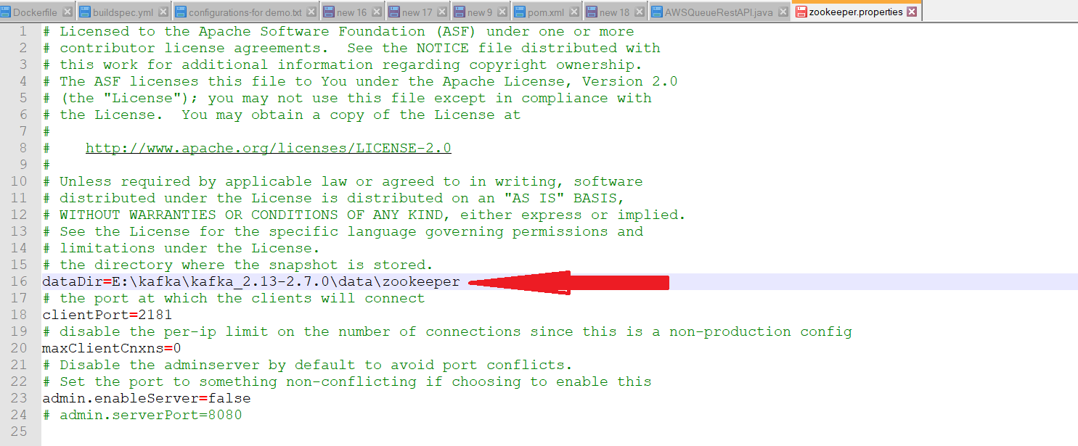

1. Change all “\” to “/” (forward slash to backward slash)

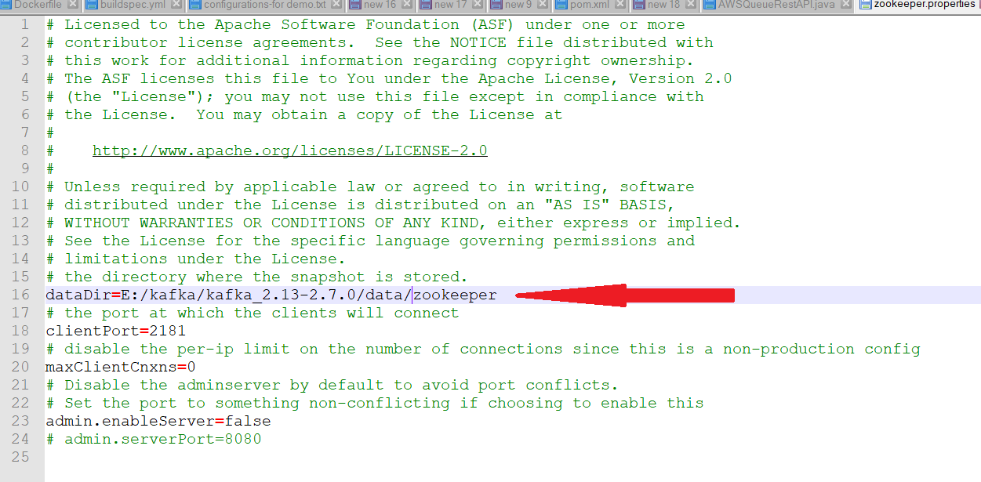

1. Move to the “kafka_2.13-2.7.0” folder and issue the following command.

**zookeeper-server-start config/zookeeper.properties**

1. You will get the following output and you can see that the zookeeper server is running in port no. 2181 as shown below.

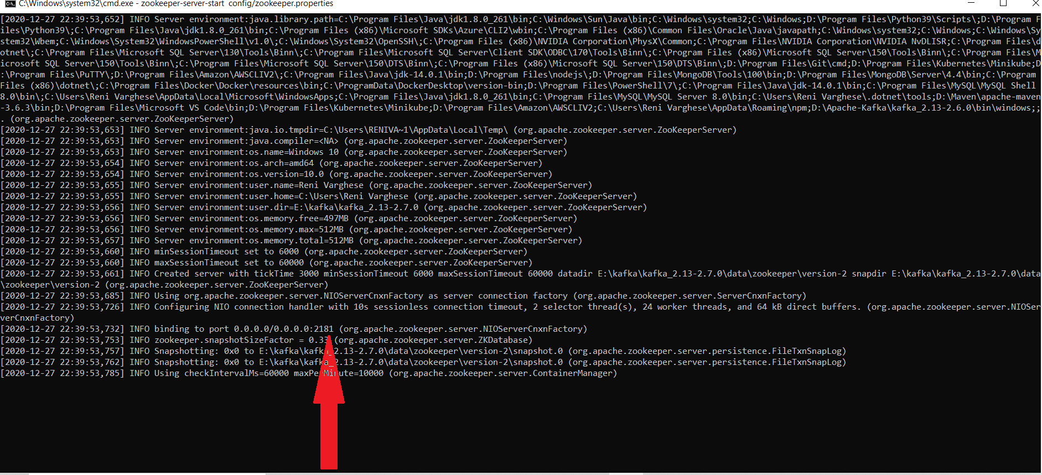

1. Go to the “config” folder again and edit “server.properties”

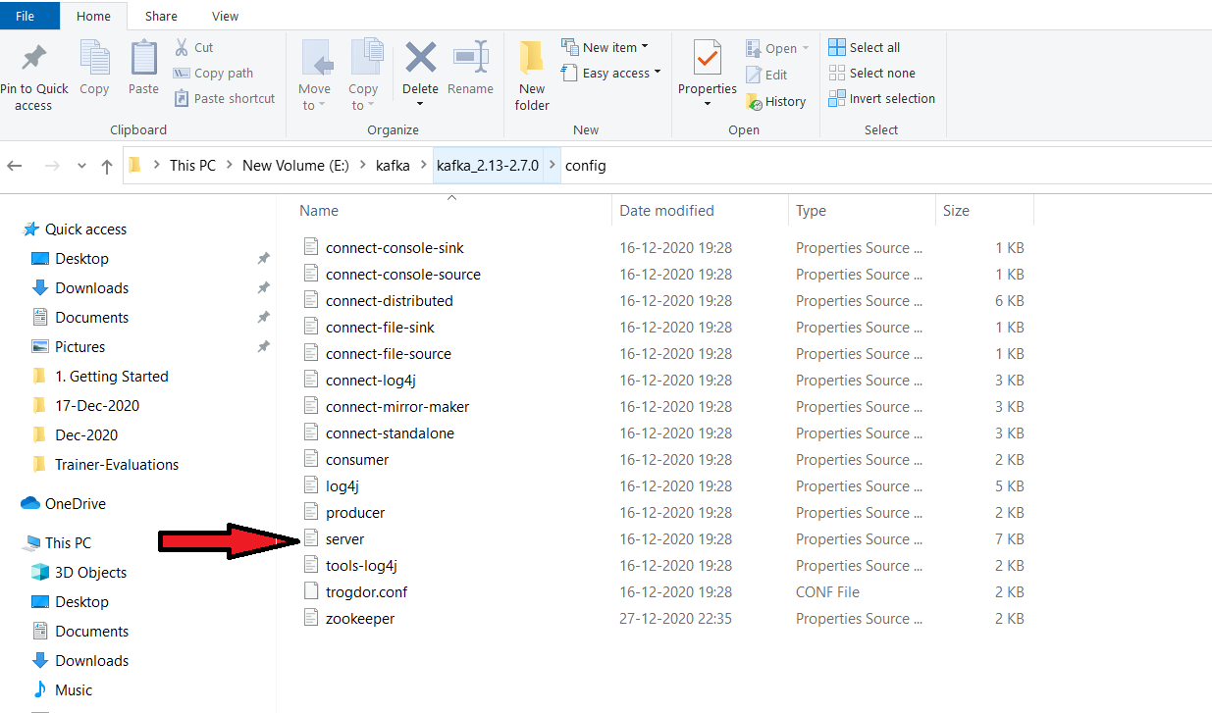

1. Change the “log.dirs” property to point to the kafka folder inside the data folder which you have created in step 3.
2. Change “\” to “/”

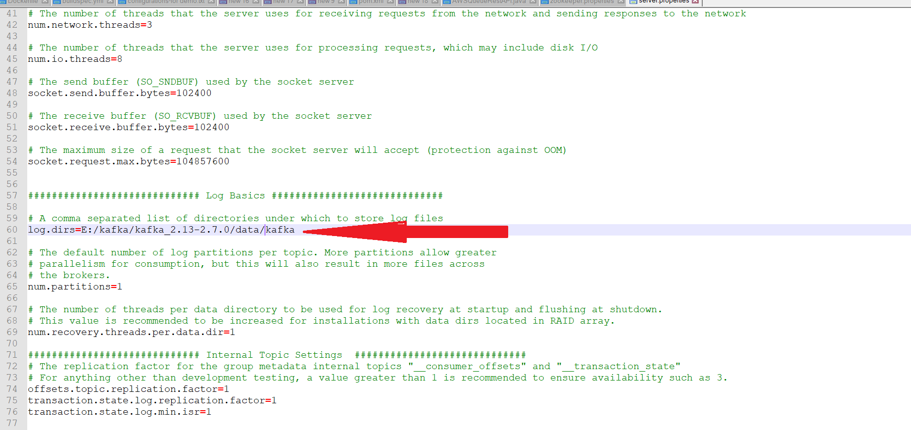

1. Open another command prompt / terminal
2. Move to the “kafka_2.13-2.7.0” folder and issue the following command.

**kafka-server-start config\server.properties**

1. You can see the kafka server has started as shown in the screen below.

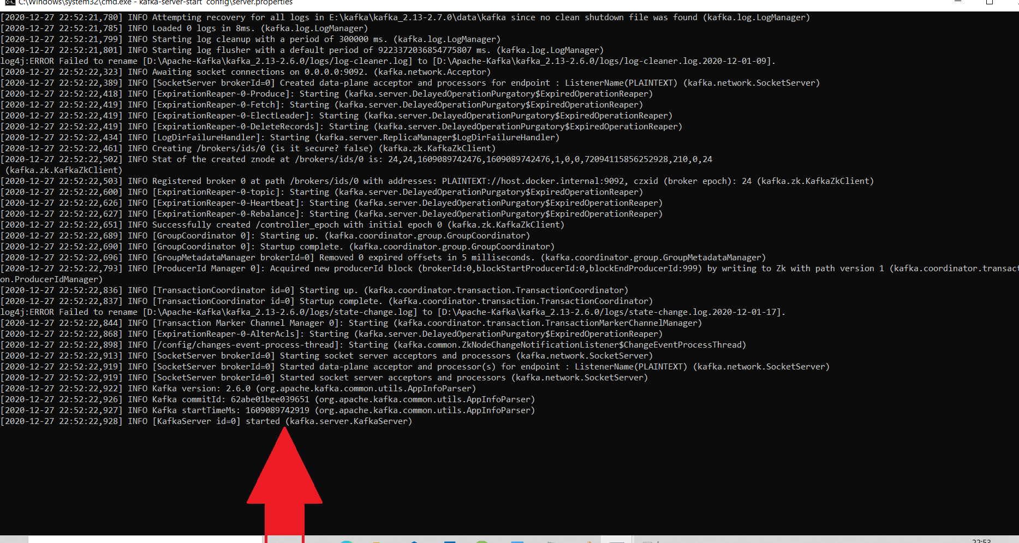

1. Make sure that these 2 servers (Zookeeper and kafka) are running
2. Open a new command prompt/terminal
3. Create a kafka topic using Kafka CLI by issuing the command below.

**kafka-topics --zookeeper localhost:2181 --topic demo_topic --create --partitions 3 --replication-factor 1**

1. You can see that the topic with name name “demo_topic” has been created as shown in the screen below.

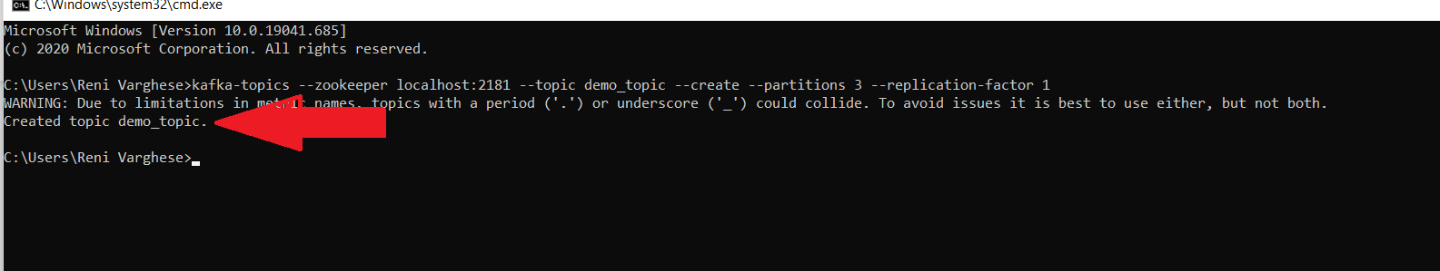

1. You can issue the command below to list the topics created.

**kafka-topics --zookeeper localhost:2181 --list**

1. You can also issue the below command to get more details about a specific topic.

**kafka-topics --zookeeper localhost:2181 --topic demo_topic --describe**

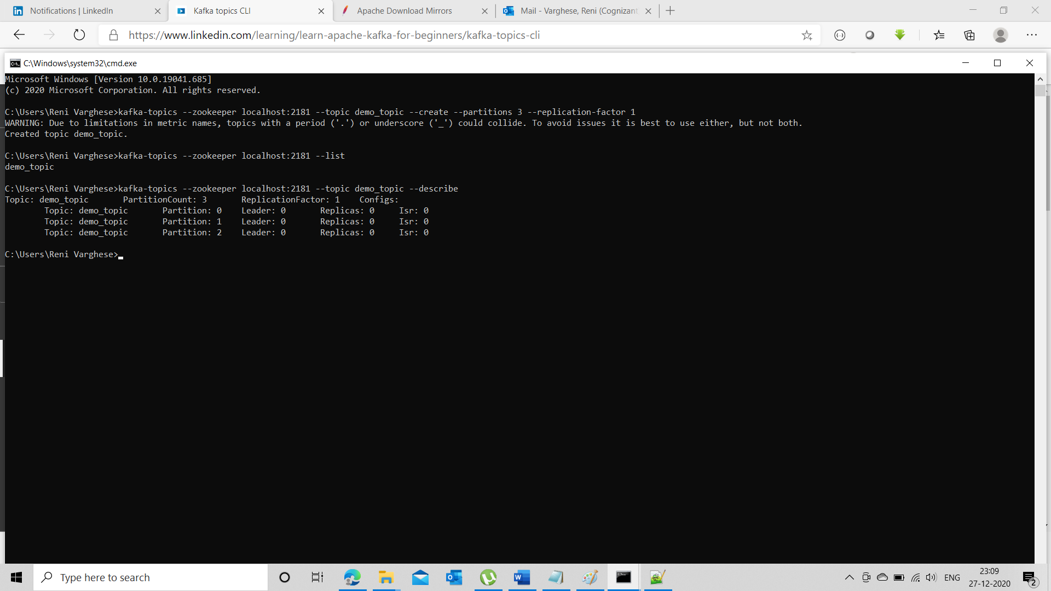

1. Start a kafka console producer by issuing the below mentioned command.

**kafka-console-producer --broker-list localhost:9092 --topic demo_topic**

1. You will get a prompt where you can keep on typing your messages as shown below.

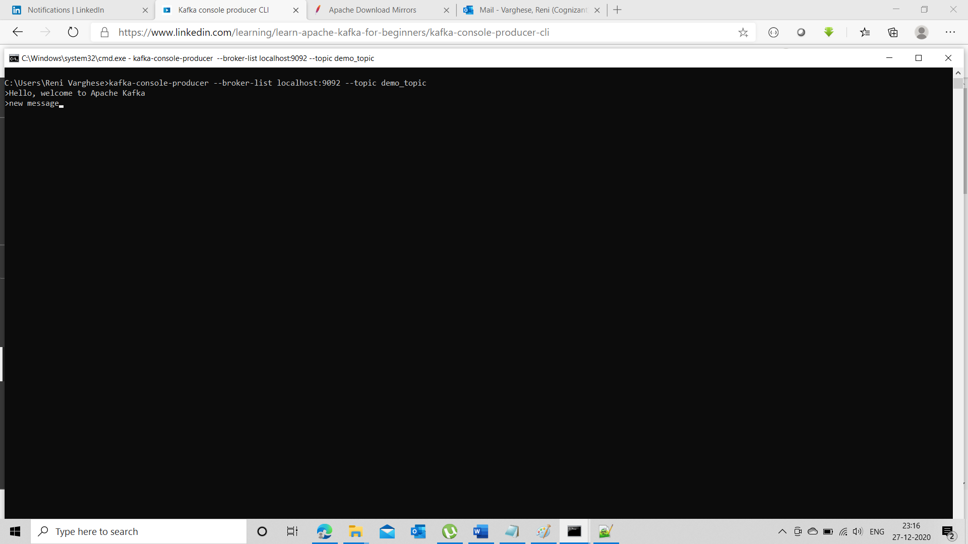

1. Open another command prompt/terminal and start the Kafka console consumer by issuing the below mentioned command.

**kafka-console-consumer --bootstrap-server localhost:9092 --topic demo_topic --from-beginning**

1. You can see that all the messages send by the producer have been consumed by the consumer and shown below

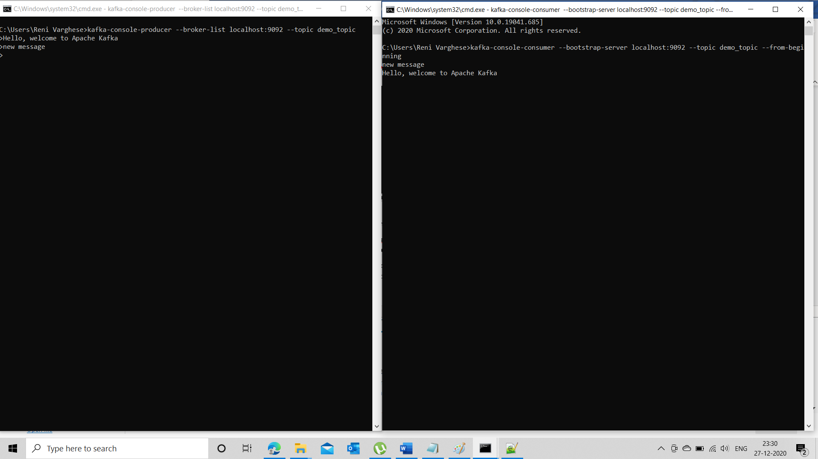

1. You can try typing messages in the producer and observe that those messages are being consumed by the consumer.

One done please stop consumer, producer, zookeeper server and kafka server